Life Cycle Plan (LCP)

LEMA Pilot School Integrated Scheduling System

Team No. 12

Name | Primary Role | Secondary Role
David Wiggins | Project Manager | Developer
Aakash Shah | Prototyper | Developer
Kushalpreet Kaur | Developer | Developer
Thammanoon Kawinfruangfukul | Tester | Developer
Eunyoung Hwang | Architect | Developer
Louis Demaria | IIV&V | Developer
Mark Villanueva | QFP | Developer
Sangik Park | Developer | Developer

04/27/2012

Version History
Date | Author | Version |  | Changes made |  | Rationale
09/29/11 | Harsimran Singh Benipal, Madhulika Mazumdar | 1.0 |  | First Draft. Identifying the Roles, Skills and Responsibilities of all the team members. |  | Initial draft with respect to LEMA Pilot School Integrated Scheduling System Version 1.0
09/30/11 | Harsimran Singh Benipal | 1.1 |  | Add Introduction part |  | Correction after grading
10/07/11 | Harsimran Singh Benipal | 1.2 |  | Fixed bug #4465;  Modified skills (section 3.3) |  | Response to Core VC package; fixing od bugs
10/12/11 | Neelima Agarwal | 2.0 |  | Identify new skills, describe milestones and products; identifying responsibility for the team members in valuation phase |  | Added info to comply with the minimum exit criteria for LCP within Core FC
10/18/11 | Neelima Agarwal | 2.2 |  | Added Stakeholders’ responsibilities, monitoring and control, updated methods and tolls, estimated resources using COTIPMO tool; Fixed Bugs |  | Minimum exit criteria for Draft FC package
10/18/11 | Neelima Agarwal | 2.3 |  | Changes in the estimated resources |  | Correction in order for the modules to trace back to the requirements
10/24/2011 | Neelima Agarwal | 2.4 |  | Detailed project plan for foundations phase, COTIPMO estimate, identification of skills and responsibilities for new members |  | Minimum exit criteria for FC package; feedback from ARB session
11/07/2011 | Neelima Agarwal | 2.5 |  | Fixed bugs #5998, #6080 through #6089. |  | Response to evaluation of FC Package
11/21/2011 | Neelima Agarwal | 3.0 |  | Updated resource estimates, according to COTIPMO iteration #6 |  | Draft Development Commitment Package (DCP)
11/29/2011 | Neelima Agarwal | 3.1 | Updated resource estimates ; made corrections |  | Draft Development Commitment Package (DCP)
12/05/2011 | Neelima Agarwal | 3.2 | Updated estimates according to the latest COTIPMO iteration ; fixed bugs |  | Draft Development Commitment Package (DCP) and Response to evaluation of draft DCP
02/04/2012 | Thammanoon | 4.0 | Updated all sections for rebasedline foundation phase |  | Updated information following new team structure and members
02/10/2012 | Thammanoon | 4.1 | Updated section 2, 5, and 6 |  | Manage inconsistency of requirements among documents
02/15/2012 | Thammanoon | 4.2 | Update section 5 |  | Updated cost estimate and feedback from ARB session
02/24/2012 | Thammanoon | 4.3 | Update table of contents |  | Updated following IIV&Ver
03/25/2012 | Thammanoon | 5.0 | Update section 1.2 and 6 |  | Update document following feedback from TA and add iteration assessment and CCD preparation.
04/03/2012 | Thammanoon | 5.1 | Update section 1.2 and 6.2 |  | Add testing and CCD results
04/11/2012 | Thammanoon | 5.2 | Update section 1.2, 5, and 6.3  Update table 5 and 7 |  | Update document following feedback from TA and plan for second iteration.
04/27/2012 | Thammanoon | 6.0 | Update section 1.2, 5, 6.2 and 6.3 |  | Assess the second iteration

Table of Contents
Life Cycle Plan (LCP) i
Version History ii
Table of Contents iv
Table of Tables v
Table of Figures vi
1. Introduction 1
1.1 Purpose of the LCP 1
1.2 Status of the LCP 1
1.3 Assumptions 1
2. Milestones and Products 2
2.1 Overall Strategy 2
2.2 Project Deliverables 4
3. Responsibilities 12
3.1 Project-specific stakeholder’s responsibilities 12
3.2 Responsibilities by Phase 14
3.3 Skills 17
4. Approach 22
4.1 Monitoring and Control 22
4.2 Methods, Tools and Facilities 23
5. Resources 24
6. Iteration Plan 40
6.1 Plan 40
6.1.1 Capabilities to be implemented 40
6.1.2 Capabilities to be tested 42
6.1.3 Capabilities not to be tested 42
6.1.4 CCD Preparation Plans 42
6.2 Iteration Assessment 46
6.2.1 Capabilities Implemented 46
6.2.2 Summary of Test Results 47
6.3 Adherence to Plan 51

Table of Tables
Table 1: Artifacts Deliverables in Exploration Phase 4
Table 2: Artifact deliverable in Valuation Phase 4
Table 3: Artifact deliverable in Foundations Phase 6
Table 4: Artifact deliverable in Development Phase 7
Table 5: Artifact deliverable in Development Phase 8
Table 6: Project Specific stakeholder’s responsibilities 12
Table 7: Stakeholder's Responsibilities in each phase 14
Table 8: Skills identified for development team (CS577a) 17
Table 9: Skills identified for development team (CS577b) 19
Table 10: Methods, Tools and Facilities 23
Table 11: COCOMOII Scale Driver 27
Table 12: Cost Drivers - Teacher Course Allocation Module 28
Table 13: Cost Drivers - Database Module 29
Table 14: Cost Drivers - Family Accountability Integration Module 31
Table 15: Cost Drivers – csv import/export for integration 32
Table 16: Cost Drivers - Student Progress Tracking 34
Table 17: Cost Drivers - Student Course Allocation module 35
Table 18: Cost Drivers - Head Scheduler Data entry module 37
Table 19: Cost Drivers - Student Course Preference module 38
Table 20: Capabilities to be implemented in the iteration 1 40
Table 21: Capabilities to be implemented in the iteration 2 41
Table 22: CCD Stakeholders 42
Table 23: CCD usage scenarios 43
Table 24: CCD feedback form layout 45
Table 25: CCD preparation risk management plans 45
Table 26: Capabilities implemented, tested, and results in the first iteration 46
Table 27: Capabilities implemented, tested, and results in the second iteration 47
Table 28: Core capabilities drive-through results 48
Table 29: CCD risk management plans 50

Table of Figures
Figure 1: Software Modules (Initial Estimates) 25
Figure 2: Scale factors 25

    - Introduction

Purpose of the LCP
Life Cycle Plan is used to identify the deadlines for the various phases and modules of the project. It also identifies the roles, skills and responsibilities of the various team members.
It provides a detailed description of the milestones, products or deliverables in each phase. It also specifies the life cycle management approach which helps in managing and controlling progress

Status of the LCP
This is the version 6.0 of the Life Cycle Plan and it is a part of the Initial Operational Capability Package. It identifies all the major milestones regarding the various phases of the project. This version describes the life cycle plan for the development phase, identifies modules for the system and the cost estimation based on the latest iteration of COTIPMO tool. Moreover, this version recorded the test results of capabilities in the second iteration.

Assumptions
  - The duration of the project is 24 weeks, i.e. 12 weeks in Fall 2011 and 12 weeks in Spring 2012
  - The team comprises of 8 members including 3 DEN students and 2 unpaid interns.
  - The team members, the client and the other success-critical stakeholders are shared goals and have the strong commitments to achieve the goals.
  - The team members, the client and the other success-critical stakeholders will be in regular communication with one another, so everyone will be informed of updates their progress, a decision had to be made, or an issue found.
  - The requirements will not change drastically during the course of the project

    - Milestones and Products

Overall Strategy
The LEMA Pilot School Integrated Scheduling System will be following the Architected Agile Methodology because 80% of its functionality has to be developed from scratch and the rest comes from Free Timetabling Software (COTS). The team will be following Incremental Commitment Spiral Model.
Exploration phase
Duration: 09/09/11- 10/03/11
Concept: The team gets to know each other working styles and is introduced to the clients. The team will schedule several meetings with the clients in order to analyze the current system and understand the current business work flow, collect the system scope, make initial life cycle plans, perform benefit chain analysis.
The team also does feasibility analysis, identifies risks and start with initial risk management plans.
Deliverables: Valuation Commitment Package
Milestone: Valuation Commitment Review
Strategy: Scrum Development

Valuation Phase
Duration: 10/03/11- 10/26/11
Concept: The team holds WinWin negotiation sessions with the clients. All win conditions, issues, and options are to be updated on the Winbook. The stakeholders must suggest alternatives and options to address any issues. System requirements are described at a detailed level. Initial prototype is developed here, operational concept is elaborated in detail and system architecture is specified. Feasibility analysis and risk mitigation planning are to be done and the system requirements need to be prioritized.
Deliverables:
- Core Foundation Commitment Package,
- Draft Foundation Commitment Package
- Foundation Commitment Package
Milestone: Architecture Board Review-Foundation Commitment Review
Strategy: Win-win negotiation, initial prototype development, defining architecture

Foundations Phase
Duration: 10/26/11- 12/05/11
Concept: By now, negotiation is done with the client and the system requirements are clearly defined and understood. The team should spend more effort on prototyping, developing the system architecture, specifying architecture styles, patterns and frameworks, managing project quality and assessing and managing project status.
Some effort has to be spent on the transition plans and planning needed for moving to the development phase (choosing development tools, analyzing compatibility of each tools, deciding development environment, etc.)
Deliverables:
- Draft Development Commitment Package
- Development Commitment Package
Milestone: Architecture Board Review-Foundation Commitment Review
Strategy: prototype development, detailed architecture

Rebaselined Foundation Phase
Duration: 01/09/2012 – 02/08/2012
Concept: Updating requirements if it is necessary. Create shared vision and transfer knowledge to new team members. The team revises all requirements, design, and artifacts, and prepares test and transition plans in order to ensure that the project is ready for development phase.
Deliverables: Rebaselined Development Commitment Package
Milestone: Rebaslined Development Commitment Review
Strategy: One short Incremental Commitment Cycle.

Development phase (Construction iteration):
Duration: 02/09/2012 - 04/09/2012
Concept: Develop and implement the system based on previous design and architecture. The development team is able to reuse the prototypes to speed up the process and reduce the risks since the prototypes are developed and tested. Before leaving from this phase, all functions need to finish development and testing, and most of the risks and defects have to eliminate in order to be ready for transition.
Deliverables:
- Initial Operational Capability (IOC) Package
- Core Capability Drive-Thru Report
- Draft Transition Readiness Review Package
Milestones: Core Capability Drive-through
Strategy: Mostly implementation and testing.

Development phase (Transition iteration):
Duration: 04/10/2012 – 04/27/2012
Concept: This involves installing and deploying the system at the operational environment. Training should be provided to the clients and users, so that the users of the system can use it successfully.
Deliverables:
- Initial Operational Capability (IOC) Package
- Support and Transition Set Package
- Close Out Report
- Project Archiving
Milestones: Transition Readiness Review
Strategy: Installation, Transition and training.

Project Deliverables
This section describes all of the artifacts the team is responsible for delivering and its due date, format, and medium.

Exploration Phase
Table 1: Artifacts Deliverables in Exploration Phase
Artifact | Due date | Format | Medium
Client Interaction Report | 09/29/11 | .doc, .pdf | Soft copy
Valuation Commitment Package  - Operational Concept Description (OCD) Early Section  - Life Cycle Plan (LCP) Early Section  - Feasibility Evidence Description (FED) Early Section | 09/30/11 | .doc, .pdf | Soft copy
Progress Report | Every Wednesday | .xls | Soft copy
WikiWinWin Report | ------ | Text | Soft copy
Project Plan | Every Wednesday | .mpp | Soft copy
Initial prototype | ------ | .doc, .pdf | Soft copy
Evaluation of Valuation Commitment Package | 10/03/2011 | .xls | Soft Copy; Bugzilla

Valuation Phase
Table 2: Artifact deliverable in Valuation Phase
Artifact | Due date | Format | Medium
Core Foundations Commitment Package  - Operational Concept Description (OCD)  - Life Cycle Plan (LCP)  - Feasibility Evidence Description (FED)  - Prototype (PRO)  - System and Software Architecture Description (SSAD)  - System and Software Requirements Definition (SSRD)  - Supporting Information Document (SID) | 10/12/2011 | .doc, .pdf | Soft copy
Progress Report | Every Wednesday | .xls | Soft copy
Project Plan | Every Wednesday | .mpp | Soft copy
Evaluation of Core Commitment Package | 10/12/2011 | .xls | Soft copy; Bugzilla
Effort Report | Every Monday | - | Effort Reporting system
Draft Foundations Commitment Package  - Operational Concept Description (OCD)  - Life Cycle Plan (LCP)  - Feasibility Evidence Description (FED)  - Prototype (PRO)  - System and Software Architecture Description (SSAD)  - System and Software Requirements Definition (SSRD)  - Supporting Information Document (SID) | 10/17/2011 | .doc, .pdf | Soft copy
Evaluation of Draft FC Package | 10/17/2011 | .xls | Soft copy; Bugzilla
Foundation Commitment Package:  - Operational Concept Description (OCD)  - Life Cycle Plan (LCP)  - Feasibility Evidence Description (FED)  - Supporting Information Document (SID)  - System and Software Architecture Description (SSAD)  - UML Model | 10/24/2011 | .doc, .pdf | Soft copy
Evaluation of Foundation Commitment Package | 10/31/2011 | .xls | Soft copy; Bugzilla

Foundations Phase
Table 3: Artifact deliverable in Foundations Phase
Artifact | Due date | Format | Medium
Draft Development Commitment Package  - Operational Concept Description (OCD)  - Life Cycle Plan (LCP)  - Feasibility Evidence Description (FED)  - Prototype (PRO)  - System and Software Architecture Description (SSAD)  - System and Software Requirements Definition (SSRD)  - Supporting Information Document (SID)  - Quality Management Plan (QMP)  - Test Plan (TP)  - Iteration Plan  - Acceptance Test Plan (ATP) | 11/21/2011 | .doc, .pdf | Soft copy
Development Commitment Package  - Operational Concept Description (OCD)  - Life Cycle Plan (LCP)  - Feasibility Evidence Description (FED)  - Prototype (PRO)  - System and Software Architecture Description (SSAD)  - System and Software Requirements Definition (SSRD)  - Supporting Information Document (SID)  - Quality Management Plan (QMP)  - Test Plan (TP)  - Iteration Plan  Acceptance Test Plan (ATP) | 12/05/2011 | .doc, .pdf | Soft copy
Effort Report | Every Monday | -- | Effort Reporting system
Progress Report | Every Wednesday | .xls | Soft Copy
Project Plan | Every Wednesday | .mpp | Soft copy

Rebaselined Development Phase
Table 4: Artifact deliverable in Development Phase
Artifact | Due date | Format | Medium
Draft Rebaselined Development Commitment (RDC) Package  - Operational Concept Description (OCD)  - System and Software Requirements Definition (SSRD)  - System and Software Architecture Description (SSAD)  - UML Model  - Life Cycle Plan (LCP)  - Feasibility Evidence Description (FED)  - Supporting Information Document (SID)  - Quality Management Plan (QMP)  - Test Plan and Cases (TPC)  - Transition Plan (TP) | 02/08/2012 | .doc, .pdf | Soft copy
Prototyping:  - User interface prototypes  - REST API  - OAUTH API  - Interface with COTS | 02/09/2012 | .php, .ep | Soft copy
Rebaselined Development Commitment Package  - Operational Concept Description (OCD)  - System and Software Requirements Definition (SSRD)  - System and Software Architecture Description (SSAD)  - UML Model  - Life Cycle Plan (LCP)  - Feasibility Evidence Description (FED)  - Supporting Information Document (SID)  - Quality Management Plan (QMP)  - Test Plan and Cases (TPC)  - Transition Plan (TP) | 02/15/2012 | .doc, .pdf | Soft copy
Evaluation of Rebaselined Development Commitment Package | 02/27/2012 | .doc, .pdf, Bugzilla | Soft copy, Bugzilla
Effort Report | Every Monday | -- | Effort Reporting system
Progress Report | Every Wednesday | .xls | Soft Copy
Project Plan | Every Wednesday | .mpp | Soft copy

Development Phase
Table 5: Artifact deliverable in Development Phase
Artifact | Due date | Format | Medium
Develop system modules:  - Online application for students subject registration  - Locking certain classes  - Student course requests are viewed/approved/rejected by counselor  - Schedule generation  - Map teachers to course sections  - View alternate schedules  - LAUSD constraints  - Detailed Database | 03/15/2012 | .php | Soft copy
Develop system modules:  - Authentication to the system  - Providing Information to team 04  - Integration with family accountability system | 03/22/2012 | .php | Soft copy
Test Result and Feedback  - Unit testing  - Integrated testing | 03/24/2012 | .doc, .pdf | Soft copy
Initial Operational Capability (IOC) Package Working set #1  - Operational Concept Description (OCD)  - System and Software Requirements Definition (SSRD)  - System and Software Architecture Description (SSAD)  - UML Model  - Life Cycle Plan (LCP)  - Feasibility Evidence Description (FED)  - Supporting Information Document (SID)  - Quality Management Plan (QMP)  - Test Plan and Cases (TPC)  - Transition Plan (TP)  - Test Procedure and Results (TPR) | 03/26/2012 | .doc, .pdf | Soft copy
Core Capability Drive-Thru Report  - Core Capability Drive-Thru document (CCD)  - Code Count  - Code Count Output  - COCOMOII Estimation Uncertainty  - COCOMOII Output | 04/04/2012 | .doc, .pdf, .csv | Soft copy
Evaluation of Initial Operational Capability (IOC) Package Working set #1 | 04/04/2012 | .doc, .pdf, Bugzilla | Soft copy, Bugzilla
Draft Transition Readiness Review Package  - Transition Plan (TP)  - User Manual (UM)  - Support Plan (SP)  - Training Materials (TM)  - Regression Test Package (RTP) | 04/09/2012 | .doc, .pdf | Soft copy
Develop system modules:  - Track the progress of a particular student  - Student Progress Enhanced  - GPA for various universities  - Level of Normalization | 04/17/2012 | .php | Soft copy
Test Result and Feedback  - Unit testing  - Integrated testing | 04/20/2012 | .doc, .pdf | Soft copy
Support and Transition Set Package  - Transition Plan (TP)  - User Manual (UM)  - Support Plan (SP)  - Training Materials (TM)  - Regression Test Package (RTP) | 04/16/2012 | .doc, .pdf | Soft copy
Evaluation of Support and Transition Set Package | 04/23/2012 | .doc, .pdf, Bugzilla | Soft copy, Bugzilla
- Initial Operational Capability (IOC) Package Working set #2  - Support and Transition Set Package | 04/27/2012 | .doc, .pdf | Soft copy
Software system installation  - Source Code Files  - Executable Components | 04/28/2012 | .php, .twig, .exe | Soft copy
Close Out Report  Project Archiving  - Source Code Files  - Executable Components  - Release Description | 05/04/2012 | .doc, .pdf, .php, .twig, .exe | Soft copy
Effort Report | Every Monday | -- | Effort Reporting system
Progress Report | Every Wednesday | .xls | Soft Copy
Project Plan | Every Wednesday | .mpp | Soft copy

    - Responsibilities

Project-specific stakeholder’s responsibilities

The following table shows the responsibilities of each stakeholder during the project development.

Table 6: Project Specific stakeholder’s responsibilities

Role | Responsibilities
All stakeholders | - Participate in WinWin negotiation sessions, commitment reviews and weekly meetings  - Collaborate and take responsibility for tasks assigned  - Commit to the agreed project progress
Client ( Mrs. Beth Kennedy, LEMA Pilot School) | - Arrange for site visit, and collaborate with the development team  Specify win conditions and explain operation concept  - Coordinate among user and developer  - Review and test the product and provide feedback  - Test and deploy the product in operational environment  - Support system’s transition  - Receive training for the new system, provide training for regular users
System Users – Students, Counselor, Teachers, Administrator (Ms. Roberta Mailman) | - Explain current business workflow and context  - Express win conditions  - Review and test prototypes and the product and provide feedback  - Test and deploy the product in operational environment
IIV&V | - Help in conducting WinWin Sessions  - Verify and validate documents and provide feedback to the development team  - Ensure the quality of the project
Development team | - Get all win conditions from stakeholders  - Understand the system and convert the project-related information into requirements, operational concepts, initial architecture, and prototype  - Develop project plan, ROI analysis, provide feasibility evidence  - Analyze current system environment, identify project risks, analyze project feasibility and mitigate risks  - Develop software and project artifacts to meet milestone requirements  - Interact with the various stakeholders for better understanding of the system  - Participate in Win Win sessions; identify issues/concerns and suggest alternatives/ options  - Schedule weekly client meetings and team meetings  - Meet the client weekly for showing them various system & documents and taking their reviews about the system  - Work together as a team aiming towards a common goal  - Plan and conduct testing  - Develop the system based on the agreed architecture  - Perform system transition, provide training for client and maintainer  - Provide product support in operational environment to customer
Maintainer  (LEMA school) | - Express interests or win conditions  - Provide information and show current intranet.  - Provide information and feedback, review and test the intranet in early version  - Prepare operational environment  - Test and deploy the product in operational environment  - Receive instruction for the new system, provide training for users  - Maintain the system

Responsibilities by Phase
Table 7: Stakeholder's Responsibilities in each phase
Team Member / Role | Primary / Secondary Responsibility
Team Member / Role | Exploration | Valuation | Foundations | Rebaselined  Foundation | Development- Construction Iteration | Development- Transition Iteration
Neelima  Agarwal:  Project Manager/  Software Architect | Project Manager :  -Define, plan, assign, and identify tasks & priorities for each team member  -Record project proceedings  -Record project progress | Project Manager :  - Planning and control  -Record project progress and individual effort  - Identify and resolve risks  -Life cycle planning  Software Architect:  - Analyze the  Proposed System architecture | Project Manager :  - Planning and assessing project progress  - Identify risks  -Discuss  with clients  Software Architect:  - Specify architecture styles, patterns and frameworks | N/A | N/A | N/A
Aakash Shah:  Prototyper/ Feasibility Analyst/ Builder | Prototyper:  - Search for a COTS  - Explore the various available technologies. | Feasibility Analyst:  - Assess and  plan to mitigate  risks  Prototyper:  - Develop initial prototype | Feasibility Analyst:  - Assess feasibility  evidence  Prototyper:  - Develop prototype  -Analyze and prioritize capabilities to prototype | Builder:  - Assess capabilities  - Study COTS  - Implement REST services | Builder:  - Develop the system components  - Perform unit testing | Builder:  - Deploy the system  - Final Project Deliverable
Madhulika Mazumdar:  Operational Concept Engineer | Operational Concept Eng:  - Making the OCD and LCP  - Contributing in Progress report | Operational Concept Eng:  - Identify objectives, constraints and priorities  - Develop operational  concept | Operational Concept Eng:  - Identify organizational and operational transformations  - Assess operational concept | N/A | N/A | N/A
Eunyoung Hwang:  Software Architect/ Requirements Engineer/  Builder/ Trainer | Software Architect:  - Constructing and Maintaining the website  Requirements Engineer:  - Help in requirement Analysis | Software Architect:  - Analyze the  Proposed System architecture  Requirements Engineer:  - Analyze the current and proposed system | Software Architect:  -Describing the architecture,  styles, and patterns  -Defining technology dependent architecture  Requirements Engineer:  - Re-evaluate the Win Conditions based on client's feedback | Builder:  - Assess capabilities  - Develop user interface prototypes  Software Architect:  - Assess architecture and detail design | Builder:  - Develop the system components  - Perform unit testing | Builder:  - Deploy the system  - Final Project Deliverable  Trainer:  - Prepare and train the system content  - Transition the system
Harsimran  Benipal:  Requirements  Engineer/ Life Cycle Planner | Requirements Engineer:  - Making the CIR  - Getting System Requirements and making the SSRD.  Life Cycle Planner:  - Making LCP | Requirements Engineer:  - Negotiate Win conditions | Requirements Engineer:  - Re-negotiate  Win Conditions based on client's feedback  Life Cycle Planner:  - Estimate project effort and schedule | N/A | N/A | N/A
Louis DeMaria:  IIV&V / Shaper/ Quality Focal Point/  Builder/  Tester | IIV&V:  - facilitation in win win sessions  - verifying the requirements | IIV&V:  - Manage  Project Quality  - Verifying & validation of products or deliverables  Shaper:  - Setup WinWin  negotiation  context  - Negotiate  WIOA  - Capture  new system items  and project context | IIV&V:  - Verify and validate  documents using  Bugzilla  Quality Focal Point:  - Construct traceability matrix  - Identify configuration management strategy  Shaper:  - Negotiate the Win conditions to validate the feasibility of requirements  - Capture  new system items and project context | IIV&V:  - Verify and validate  documents recording to  Bugzilla  Builder:  - Assess capabilities | IIV&V:  - Verify and validate the work products  Builder:  - Develop the system components  - Perform unit testing  Tester:  - Test modules/ system and record test results | IIV&V:  - Manage issues and defects  - Verify and validate the work products  Builder:  - Deploy the system  - Final Project Deliverable  Tester:  - Test system and record test results
Tianyin Zhou:  Prototyper | N/A | N/A | Prototyper:  - Develop prototype  -Prioritize capabilities to prototype | N/A | N/A | N/A
David Wiggins:  Project Manager/ Feasibility Analyst/ Builder/ Trainer | N/A | N/A | N/A | Project Manager:  - Define detail project plan  - Track Progress  Feasibility Analyst:  - Assess and evaluate COTS  - Track risks throughout life cycle  Builder:  - Develop user interface prototypes | Project Manager:  - Define detail project plan  - Track Progress  Builder:  - Develop the system components  - Perform unit testing | Project Manager:  - Define detail project plan  - Track Progress  Builder:  - Deploy the system  - Final Project Deliverable  Trainer:  - Prepare and train the system content  - Transition the system
Thammanoon Kawinfruangfukul:  Requirements  Engineer/ Life Cycle Planner/ Builder/Tester/ Trainer | N/A | N/A | N/A | Requirements Engineer:  - Define detail requirements  - Handle requirement changes  Life Cycle Planner:  - Assess life cycle plan  - Define detail life cycle plan  - Define iteration and support plan  Builder:  - Develop user interface prototypes  - Setup development environment  - Study Symfony | Life Cycle Planner:  - Define detail life cycle plan  Builder:  - Develop the system components  - Perform unit testing  Tester:  - Test modules/ system and record test results | Life Cycle Planner:  - Define detail life cycle plan  Builder:  - Deploy the system  - Final Project Deliverable  Tester:  - Test system and record test results  Trainer:  - Prepare and train the system content  - Transition the system
Mark Villanueva:  Quality Focal Point/ Builder/ Tester | N/A | N/A | N/A | Quality Focal Point:  - Assess quality management plan and strategies  Builder:  - Study Symfony  - Implement REST services | Quality Focal Point:  - Identify test plan  Builder:  - Develop the system components  - Perform unit testing  Tester:  - Test modules/ system , record test results | Builder:  - Deploy the system  - Final Project Deliverable  Tester:  - Test system and record test results
Kushalpreet Kaur:  Builder | N/A | N/A | N/A | Builder:  - Study Symfony  - Interface with COTS | Builder:  - Develop the system components  - Perform unit testing | Builder:  - Deploy the system  - Final Project Deliverable
Sangik Park:  Builder | N/A | N/A | N/A | Builder:  - Study Symfony  - Interface with database and Symfony | Builder:  - Develop the system components  - Perform unit testing | Builder:  - Deploy the system  - Final Project Deliverable

Skills
Table 8: Skills identified for development team (CS577a)
Name | Roles | Skills
Neelima Agarwal | Project Manager/ Software Architect | Technical Skils:  C, C++, Java, JS, XML, HTML, MySQL  -Planning and managerial skills  -Inter-personal Skills  -Good at assessing and identifying project risks, defects, and concerns  -Team Management skills  -Mentoring skills  -Risk mitigation planning skills  -Conflict Resolution Skills  -Good at partnering with end users, and clients to ensure progress in the right direction  - UML modeling skills  -Skilled at analyzing the current and proposed system architecture
Aakash Shah | Prototyper / Feasibility Analyst | Technical Skills:  C#,J#, C, C++, HTML, DB design and SQL scripting to develop the prototype  -Mentoring skills  - Skilled at analyzing components for implementation and risk  -Assessment skills for understanding the system  - Skilled in Silverlight UI, C#, C,C++, DB design and SQL scripting to develop the prototype  -Good analytical skills for analyzing the cost and benefits of the project  -NDI analysis skills for checking feasibility  - Effective Communication skills
Madhulika Mazumdar | Operation Concept Engineer / Project Manager | Technical Skills:  C,C++, Java, HTML, XML, JS  -Skilled at identifying the goals, restrictions, and priorities of the system  -Good at evaluation of the new concepts for the proposed system as well as the current system  -Effective communication skills  -Team collaboration skills  -Inter-personal skills.
Harsimran Singh Benipal | Requirements Engineer / Life Cycle Planner | Technical Skills  C, C++, C#, ASP.NET, SQL Server, MySQL  -Negotiation skills  -Analytical skills to understand and comprehend the proposed system  -Resource management skills  -Listening skills  -Communication skills  -Team collaboration skills
Eunyoung Hwang | Software Architect / Requirements Engineer | Technical Skills  Java, SQL Server , Javascript , C, C++, J#, HTML  -Skilled in system analysis  - Analytical skills to understand how the users will interact with the system  -Skilled at mapping requirements to architecture and detailed designing.  -Problem solving skills  - Listening skills  -Communication skills  -UML modeling skills
Tianyin Zhou | Prototyper | Technical Skills:  Python, PHP  - Team collaboration skills  - Listening skills  -Communication skills  -Analytical skills to understand and comprehend the proposed system

Table 9: Skills identified for development team (CS577b)
Name | Roles | Skills
David Wiggins | - Project Manager  - Feasibility Analyst  - Builder  - Trainer | Current skills:  - PHP, CSS, HTML, MySQL  - Project management skills  - People skills  - Ability to handle conflicts  - Ability to analyze business and investment  - Ability to assess and mitigate risks  - Communication skills  Required skills:  - Symfony
Aakash Shah | - Builder | Current skills:  - C#,J#, C, C++, HTML, DB design and SQL scripting to develop the prototype  - Mentoring skills  - Skilled at analyzing components for implementation and risk  - Assessment skills for understanding the system  - Skilled in Silverlight UI, C#, C,C++, DB design and SQL scripting to develop the prototype  - Good analytical skills for analyzing the cost and benefits of the project  - NDI analysis skills for checking feasibility  - Effective Communication skills  Required skills:  - Symfony  - PHP
Eunyoung Hwang | - Software Architect  - Requirements Engineer  - Builder | Current skills:  - Java, SQL Server , Javascript , C, C++, J#, HTML  - Skilled in system analysis  - Analytical skills to understand how the users will interact with the system  - Skilled at mapping requirements to architecture and detailed designing.  - Problem solving skills  - Listening skills  - Communication skills  - UML modeling skills  Required skills:  - Symfony  - PHP
Thammanoon Kawinfruangfukul | - Requirements Engineer  - Life Cycle Planner  - Builder  - Tester  - Trainer | Current skills  - Planning skills  - Project coordination  - COTIPMO  - MS project  - UML, RSM  - PHP, MySQL  - Communication skills  - Analytical skills  - Negotiation skills  Required skills  - Symfony  - Testing methodology  - Bug tracking and removal techniques
Mark Villanueva | - Quality Focal Point  - Builder  - Tester | Current skills  - Analytical skills  - Communication skills  - Testing methodology  - Bug tracking and removal techniques  - UML, RSM  - WinBook  - PHP, HTML  Required skills:  - Symfony  - PHP
Louis Demaria | - IIV&V  - Shaper  - Quality Focal Point  - Builder  - Tester | Current skills  - C, C++ , HTML, J script, JAVA, Visual Basic, C++, C#, J#, MySQL  - Communication and negotiation skills  - Analytical skills to understand the system and finding any potential errors.  - Listening skills  - Communication skills  - Team collaboration skills  - Inter-personal skills  - Defect tracking and reporting skills  Required skills:  - Symfony  - PHP
Kushalpreet Kaur | - Builder | Current skills  - PHP, CSS, HTML, MySQL  - Analytical skills  - Communication skills  Required skills:  - Symfony
Sangik Park | - Builder | Current skills  - PHP, CSS, HTML, MySQL  - Analytical skills  - Communication skills  Required skills:  - Symfony

    - Approach

Monitoring and Control
The team is adopting various approaches for monitoring and control. Weekly meetings with the client provide the necessary feedback, monitoring and control. Further, regular sync ups with the team members through meetings, and emails allow for effective communication. The summary of report will be recorded on the meeting minutes sent to group email, progress report, effort report, and project plan.

Closed Loop Feedback Control
- Weekly Progress reports identifying risks and risk mitigation plans; defects, problems and concerns and progress in terms of tasks completed last week and tasks to be completed in the following week. Any deviation from the baseline is identified, its severity is analyzed and action, as appropriate, is taken.
- Weekly detailed project plan stating the plan for the coming weeks and tasks for each of the team members. Moreover, MS Project plan gives the tasks to be completed by calendar year, this also helps the manager to record any lags and if any, compensate them as soon as possible, so as to avoid future major delays.
- Weekly effort reports for assessing the number of hours spent per week by the development team members on the project development.
- Regular team meetings to discuss and plan the tasks for the coming week and for follow-ups on the tasks completed in between two consecutive meetings
- Use of emails, phone calls, wikispace, and CSCI 577 Team 12 Google group page(http://groups.google.com/group/csci577-team12) for effective communication.

Reviews
Reviews and recommendations for every artifact are done at various levels.
First, IIV&V activities are carried out and IIV&V files a bug report in case there is a bug in the artifact being reviewed. Then, the artifacts are reviewed and graded by the teaching staff members. The team also uses Architecture Review Boards which are performed after every major milestone of project development.

Sometimes, the team uses peers review where team members review each other’s work and provide suggestions.

Methods, Tools and Facilities
Table 10: Methods, Tools and Facilities
Tools | Usage | Provider
Bugzilla | Utilized to detect bugs, and errors | USC
CSE Effort Reporting System and iCard system | Record and keep track of the cumulative weekly effort reports for each team member | USC
Google Docs | Utilized for cohesive collaboration on documents | Google
Google Groups | Tool for communication and collaboration among the team members | Google
Project Website | Uploading documentation | USC
Rational Software Modeler | Create UML models (use-case diagrams, sequence diagrams, etc) for SSAD | USC
Microsoft Word | Create documents for the documentation purposes | Developers
Microsoft Project | Used for documenting detailed weekly project plan, defining tasks for each team member and setting milestones or deadlines | USC
Microsoft PowerPoint | Create presentation for ARB sessions | Developers
Winbook | Facilitates and support WinWin Negotiation | USC
COTIPMO | Cost Estimation tool | USC
Subversion | Configuration manager | CollabNet

Resources
Estimate on the software cost (estimated for Iteration #14 using COTIPMO)

- Estimated CSCI577a Effort : 7 team members at 20 hrs/week for 12 weeks
- Estimated CSCI577b Effort : 8 team members at 8 hrs/week for 12 weeks
- Estimated effort from COTIPMO Iteration #10 = 4.31 PM (656 hours)
- 8 person development team is required to complete all the requirements of the project
(Estimation required team members are 3.02 (6.04 /1.67) and there are 8 team members, so the project is feasible enough to be delivered)
- Project duration – 24 weeks
- Component modules in your development project :
  - Student Progress Tracking module
  - Student Course Preference module
  - Student Course Allocation module
  - Teacher Course Allocation module
  - csv import/export for integration
  - Head Scheduler data entry module
  - Family accountability integration module
  - Database
- Programming language used: PHP
- Development framework used: Symfony 2.0

Initial Estimates:

Figure 1: Software Modules (Initial Estimates)

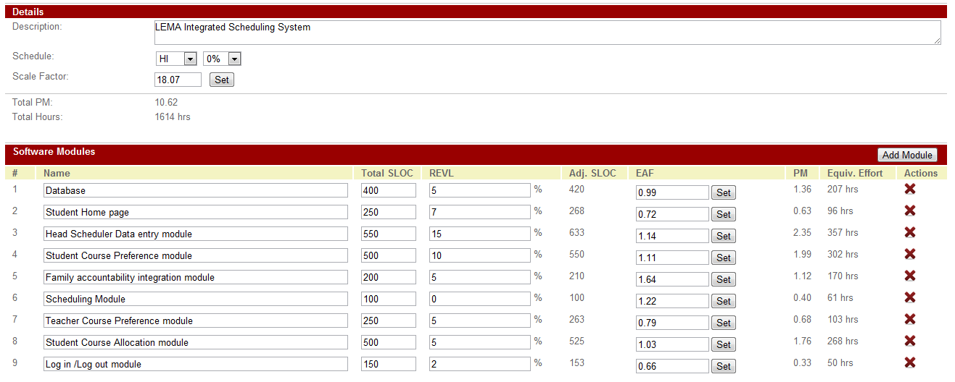

Figure 2: Scale factors

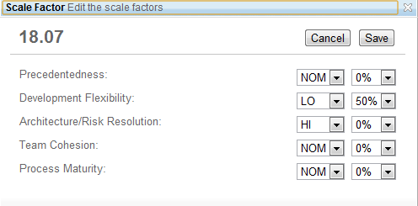

COTIPMO Iteration List
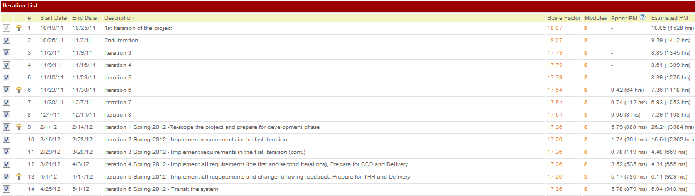

Project Progress Graph

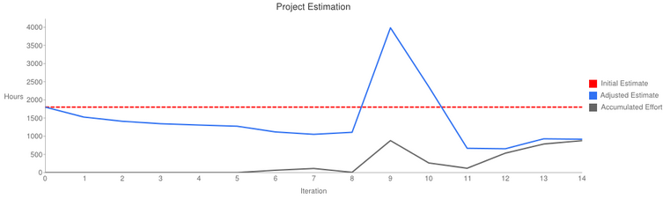

New estimates based on COTIPMO Iteration#14 and survey results:

Scale Factors

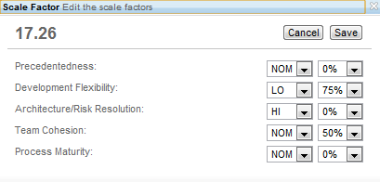
Table 11: COCOMOII Scale Driver
Scale Driver | Value | Rationale
PREC | NOM | The product is somewhat similar to several that have been developed before
FLEX | LOW+75% | There is considerable flexibility on the requirements, schedules, and interfaces. However, most of the requirements are a must have.
RESL | HIGH | Risk resolution is done extensively throughout the project lifecycle. A good amount of effort is spent in reviewing architecture and mitigating risk.
TEAM | NOM+50% | The team members have a communication and meetings and the team uses many collaborative tools to synchronize among team members.
PMAT | NOM | The level of detail done for 577 roughly corresponds to CMM level 2. Nominal amount of project management and life cycle tasks are performed.

Iteration #14 Resource Details
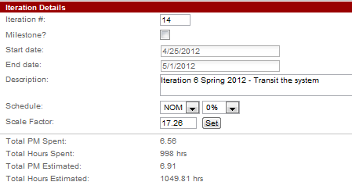

Software Modules (Iteration #14):

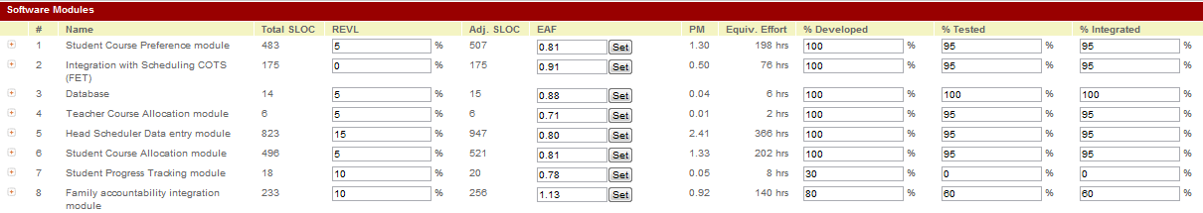
Note: The csv import/export for integration is the module for integration with Columbia (legacy system used by LAUSD) and the scheduling COTS (FET)
Table 12: Cost Drivers - Teacher Course Allocation Module
Cost Driver | Value | Rationale
RELY | LOW | Effect of software failure causes little inconvenience and losses can be recovered easily.
DATA | LOW | The data size is small. The database contains around maximum of 50 teachers.
DOCU | HIGH | The team produces and maintains documents. Comparing with project’s complexity, there are excessive amount of documentation for life-cycle needs.
CPLX | LOW+25% | Simple UI designs; no direct hardware operations; simple queries for retrieval and update to database; no complex data structure designs
RUSE | LOW | Not developing for product line; independent standalone application; very little component reuse.
TIME | NOM | Execution time constraint is not very strict and is expected to be less than or equal to 50%
STOR | NOM | It is expected to be less than 50% use of available storage. Little computation resource is required by the system. A lot of available execution time and main storage makes this of less relevance.
PVOL | NOM | The system will use stable platforms (i.e. stable OS and DBMS)
ACAP | NOM+25% | The ability in analysis, design and requirements gathering is quite good. There is a considerable amount of cooperation and communication among team members
PCAP | NOM | Some team members have industrial experience in dealing and developing various COTS package, SDKs, and frameworks.
PCON | LOW | The project’s annual personnel turnover is around 25%/year. Only two people will continue to the 577b
APEX | HIGH | All computer science students in the development team, so good amount of application experience of the development team. All team members have experiences about web application and related domain.
LTEX | NOM+50% | Most of the team members have experience with programming languages such as PHP, Java and databases like MySQL, GUI development etc. Six members out of eight are experienced in PHP.
PLEX | NOM | Team has nominal experience with development of database (MySQL) and GUIs.
TOOL | NOM | Basic lifecycle tools for development and report are used. Some software engineering aid tools like Bugzilla, COCOMO tool, etc. are also used
SITE | NOM | The team uses many collaborative tools, such as skype, google group, and wikispaces to cooperate among team members. Some of team members live different cities and time zones.
SCED | NOM | Schedule of the project is fixed i.e. 24 weeks. So, schedule stretch-out is 100% .

EAF: Teacher Course Allocation Module

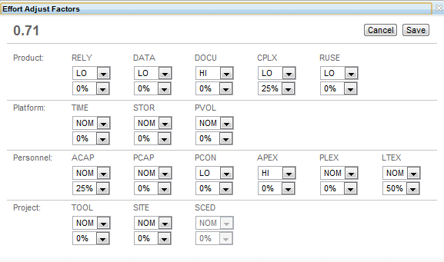
Table 13: Cost Drivers - Database Module
Cost Driver | Value | Rationale
RELY | NOM | Effect of software failure causes moderate inconvenience and losses can be recovered easily. Database should be reliable for the various operations to be carried out successfully.
DATA | NOM | The system needs to maintain database for 450 students. The database also has to maintain the course related data for students, teacher preferences, and constraints.
DOCU | HIGH | The team produces and maintains documents. Comparing with project’s complexity, there are excessive amount of documentation for life-cycle needs.
CPLX | LOW+50% | Simple UI designs; no direct hardware operations; simple queries for retrieval and update to database; no complex data structure designs
RUSE | LOW + 50% | Not developing for product line; independent standalone application; very little component reuse.
TIME | NOM | Execution time constraint is not very strict and is expected to be less than or equal to 50%
STOR | NOM | It is expected to be less than 50% use of available storage. Little computation resource is required by the system. Lots of available execution time and main storage makes this of less relevance.
PVOL | NOM | The system will use stable platforms (i.e. stable OS and DBMS)
ACAP | NOM+25% | The ability in analysis, design and requirements gathering is quite good. There is a considerable amount of cooperation and communication among team members
PCAP | NOM | Some team members have industrial experience in dealing and developing various COTS package, SDKs, and frameworks.
PCON | LOW | The project’s annual personnel turnover is around 25%/year. Only two people will continue to the 577b
APEX | HIGH | All computer science students in the development team, so good amount of application experience of the development team. All team members have experiences about web application and related domain.
LTEX | NOM + 75% | Most of the team members have experience with programming languages such as PHP, Java and databases like MySQL, GUI development etc.
PLEX | NOM+25% | Team has nominal experience with development of database (MySQL) and GUIs.
TOOL | NOM | Basic lifecycle tools for development and report are used. Some software engineering aid tools like Bugzilla, COCOMO tool, etc. are also used
SITE | NOM | The team uses many collaborative tools, such as skype, google group, and wikispaces to cooperate among team members. Some of team members live different cities and time zones.
SCED | NOM | Schedule of the project is fixed i.e. 24 weeks. So, schedule stretch-out is 100% .

EAF: Database Module

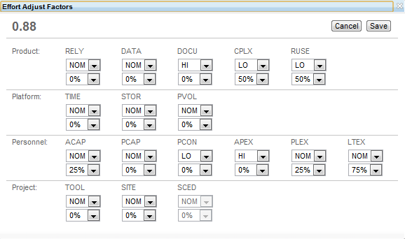

Table 14: Cost Drivers - Family Accountability Integration Module
Cost Driver | Value | Rationale
RELY | NOM+50% | Effect of software failure causes moderate inconvenience and losses can be recovered easily. Reliability should be on the higher side because this module has to interface with the external system to get information from the external database. Failure can cause the system to be unusable.
DATA | LOW+50% | The system needs to maintain database for 450 students. However, we need very specific information from the external system such as student ID, course ID etc.
DOCU | HIGH | The team produces and maintains documents. Comparing with project’s complexity, there are excessive amount of documentation for life-cycle needs.
CPLX | NOM+25% | Complex DB queries and updates, simple callbacks, distributed processing
RUSE | LOW+50% | Not developing for product line; independent standalone application; very little component reuse. But, might be re-used across project.
TIME | NOM | Execution time constraint is not very strict and is expected to be less than or equal to 50%
STOR | NOM | It is expected to be less than 50% use of available storage. Little computation resource is required by the system. Lots of available execution time and main storage makes this of less relevance.
PVOL | NOM | The system will use stable platforms (i.e. stable OS and DBMS)
ACAP | NOM+25% | The ability in analysis, design and requirements gathering is quite good. There is a considerable amount of cooperation and communication among team members
PCAP | NOM | Some team members have industrial experience in dealing and developing various COTS package, SDKs, and frameworks.
PCON | LOW | The project’s annual personnel turnover is around 25%/year. Only two people will continue to the 577b
APEX | NOM | All computer science students in the development team, so some amount of application experience of the development team. But, most of the members don’t have experience with REST services.
LTEX | NOM+75% | Most of the team members have experience with programming languages such as PHP, Java and databases like MySQL, GUI development etc. Six members out of eight are experienced in PHP.
PLEX | NOM | Team has nominal experience with development of database (MySQL) and GUIs.
TOOL | NOM | Basic lifecycle tools for development and report are used. Some software engineering aid tools like Bugzilla, COCOMO tool, etc. are also used
SITE | NOM | The team uses many collaborative tools, such as skype, google group, and wikispaces to cooperate among team members. Some of team members live different cities and time zones.
SCED | NOM | Schedule of the project is fixed i.e. 24 weeks. So, schedule stretch-out is 100% .

EAF: Family Accountability Integration Module

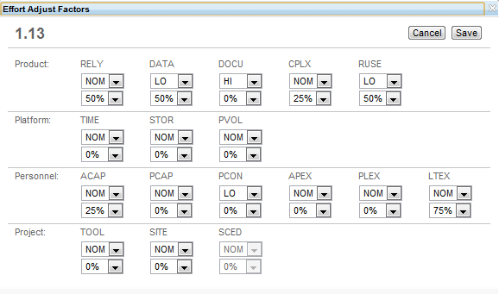
Table 15: Cost Drivers – csv import/export for integration
Cost Driver | Value | Rationale
RELY | LOW+25% | Effect of software failure causes little inconvenience and losses can be recovered easily.
DATA | LOW+50% | It uses data related to course, teacher preferences, constraints, student courses, rooms etc.
DOCU | HIGH | The team produces and maintains documents. Comparing with project’s complexity, there are excessive amount of documentation for life-cycle needs.
CPLX | NOM | Simple UI designs; no direct hardware operations; simple queries for retrieval and update to database; no complex data structure designs
RUSE | LOW | Not developing for product line; independent standalone application; very little component reuse.
TIME | NOM | Execution time constraint is not very strict and is expected to be less than or equal to 50%
STOR | NOM | It is expected to be less than 50% use of available storage. Little computation resource is required by the system. Lots of available execution time and main storage makes this of less relevance.
PVOL | NOM | The system will use stable platforms (i.e. stable OS and DBMS)
ACAP | NOM+25% | The ability in analysis, design and requirements gathering is quite good. There is a considerable amount of cooperation and communication among team members
PCAP | NOM | Some team members have industrial experience in dealing and developing various COTS package, SDKs, and frameworks.
PCON | LOW | The project’s annual personnel turnover is around 25%/year. Only two people will continue to the 577b
APEX | HIGH | All computer science students in the development team, so good amount of application experience of the development team. All team members have experiences about web application and related domain.
LTEX | NOM+50% | Most of the team members have experience with programming languages such as PHP, Java, Perl and databases like MySQL, GUI development etc. Six members out of eight are experienced in PHP.
PLEX | LOW+25% | Team has nominal experience with development of database (MySQL) and GUIs. Most developers don’t have experience with COTS products.
TOOL | NOM | Basic lifecycle tools for development and report are used. Some software engineering aid tools like Bugzilla, COCOMO tool, etc. are also used
SITE | NOM | The team uses many collaborative tools, such as skype, google group, and wikispaces to cooperate among team members. Some of team members live different cities and time zones.
SCED | NOM | Schedule of the project is fixed i.e. 24 weeks. So, schedule stretch-out is 100% .

EAF: csv import/export for integration

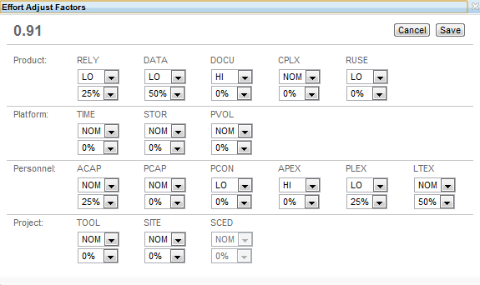

Table 16: Cost Drivers - Student Progress Tracking
Cost Driver | Value | Rationale
RELY | LOW+25% | Effect of software failure causes little inconvenience and losses can be recovered easily.
DATA | LOW+50% | The system needs to maintain database for 450 students. The database also has to maintain the course related data for students and their grades.
DOCU | HIGH | The team produces and maintains documents. Comparing with project’s complexity, there are excessive amount of documentation for life-cycle needs.
CPLX | LOW+25% | Simple UI designs; no direct hardware operations; simple queries for retrieval and update to database; no complex data structure designs
RUSE | LOW+25% | Not developing for product line; independent standalone application; very little component reuse.
TIME | NOM | Execution time constraint is not very strict and is expected to be less than or equal to 50%
STOR | NOM | It is expected to be less than 50% use of available storage. Little computation resource is required by the system. Lots of available execution time and main storage makes this of less relevance.
PVOL | NOM | The system will use stable platforms (i.e. stable OS and DBMS)
ACAP | NOM+25% | The ability in analysis, design and requirements gathering is quite high. The efficiency and throughput of the team members, level of cooperation and communication is nominal.
PCAP | NOM | Some team members have industrial experience in dealing and developing various COTS package, SDKs, and frameworks.
PCON | LOW | The project’s annual personnel turnover is around 25%/year. Only two people will continue to the 577b
APEX | HIGH | All computer science students in the development team, so good amount of application experience of the development team. All team members have experiences about web application and related domain.
LTEX | NOM+50% | Most of the team members have experience with programming languages such as PHP Java and databases like MySQL, GUI development etc. Six members out of eight are experienced in PHP.
PLEX | NOM | Team has nominal experience with development of database (MySQL) and GUIs.
TOOL | NOM | Basic lifecycle tools for development and report are used. Some software engineering aid tools like Bugzilla, COCOMO tool, etc. are also used
SITE | NOM | The team uses many collaborative tools, such as skype, google group, and wikispaces to cooperate among team members. Some of team members live different cities and time zones.
SCED | NOM | Schedule of the project is fixed i.e. 24 weeks. So, schedule stretch-out is 100% .

EAF: Student Progress Tracking

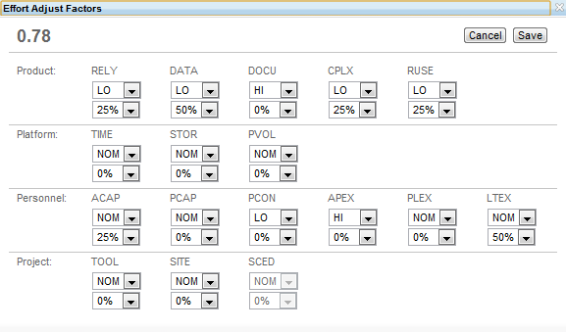
Table 17: Cost Drivers - Student Course Allocation module
Cost Driver | Value | Rationale
RELY | LOW+25% | Effect of software failure causes little inconvenience and losses can be recovered easily.
DATA | LOW+50% | The data size is small. The database contains around maximum of 50 teachers and course details.
DOCU | HIGH | The team produces and maintains documents. Comparing with project’s complexity, there are excessive amount of documentation for life-cycle needs.
CPLX | LOW+50% | Simple UI designs; no direct hardware operations; simple queries for retrieval and update to database; no complex data structure designs
RUSE | LOW+25% | Not developing for product line; independent standalone application; very little component reuse.
TIME | NOM | Execution time constraint is not very strict and is expected to be less than or equal to 50%
STOR | NOM | It is expected to be less than 50% use of available storage. Little computation resource is required by the system. Lots of available execution time and main storage makes this of less relevance.
PVOL | NOM | The system will use stable platforms (i.e. stable OS and DBMS)
ACAP | NOM+25% | The ability in analysis, design and requirements gathering is quite high. The efficiency and throughput of the team members, level of cooperation and communication is nominal.
PCAP | NOM | Some team members have industrial experience in dealing and developing various COTS package, SDKs, and frameworks.
PCON | LOW | The project’s annual personnel turnover is around 25%/year. Only two people will continue to the 577b
APEX | HIGH | All computer science students in the development team, so good amount of application experience of the development team. All team members have experiences about web application and related domain.
LTEX | NOM+50% | Most of the team members have experience with programming languages such as PHP, Java and databases like MySQL, GUI development etc. Six members out of eight are experienced in PHP.
PLEX | NOM | Team has nominal experience with development of database (MySQL) and GUIs.
TOOL | NOM | Basic lifecycle tools for development and report are used. Some software engineering aid tools like Bugzilla, COCOMO tool, etc. are also used
SITE | NOM | The team uses many collaborative tools, such as skype, google group, and wikispaces to cooperate among team members. Some of team members live different cities and time zones.
SCED | NOM | Schedule of the project is fixed i.e. 24 weeks. So, schedule stretch-out is 100% .

EAF: Student Course Allocation module

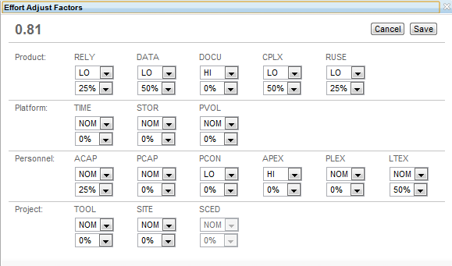

Table 18: Cost Drivers - Head Scheduler Data entry module
Cost Driver | Value | Rationale
RELY | LOW+25% | Effect of software failure causes little inconvenience and losses can be recovered easily.
DATA | LOW+50% | The database contains teacher, student, and course information. This module is only used for data entry and not for retrieval of data.
DOCU | HIGH | The team produces and maintains documents. Comparing with project’s complexity, there are excessive amount of documentation for life-cycle needs.
CPLX | LOW+50% | Simple UI designs; no direct hardware operations; simple queries for retrieval and update to database; no complex data structure designs
RUSE | LOW | Not developing for product line; independent standalone application; very little component reuse.
TIME | NOM | Execution time constraint is not very strict and is expected to be less than or equal to 50%
STOR | NOM | It is expected to be less than 50% use of available storage. Little computation resource is required by the system. Lots of available execution time and main storage makes this of less relevance.
PVOL | NOM | The system will use stable platforms (i.e. stable OS and DBMS)
ACAP | NOM+25% | The ability in analysis, design and requirements gathering is quite high. The efficiency and throughput of the team members, level of cooperation and communication is nominal.
PCAP | NOM | Some team members have industrial experience in dealing and developing various COTS package, SDKs, and frameworks.
PCON | LOW | The project’s annual personnel turnover is around 25%/year. Only two people will continue to the 577b
APEX | HIGH | All computer science students in the development team, so good amount of application experience of the development team. All team members have experiences about web application and related domain.
LTEX | NOM+50% | Most of the team members have experience with programming languages such as PHP, Java and databases like MySQL, GUI development etc. Six members out of eight are experienced in PHP.
PLEX | NOM | Team has nominal experience with development of database (MySQL) and GUIs.
TOOL | NOM | Basic lifecycle tools for development and report are used. Some software engineering aid tools like Bugzilla, COCOMO tool, etc. are also used
SITE | NOM | The team uses many collaborative tools, such as skype, google group, and wikispaces to cooperate among team members. Some of team members live different cities and time zones.
SCED | NOM | Schedule of the project is fixed i.e. 24 weeks. So, schedule stretch-out is 100% .

EAF: Head Scheduler Data entry module

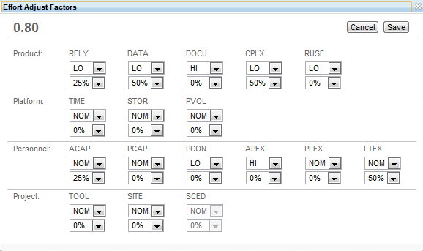

Table 19: Cost Drivers - Student Course Preference module
Cost Driver | Value | Rationale
RELY | LOW+25% | Effect of software failure causes little inconvenience and losses can be recovered easily.
DATA | LOW+50% | The database contains 450 students and course details.
DOCU | HIGH | The team produces and maintains documents. Comparing with project’s complexity, there are excessive amount of documentation for life-cycle needs.
CPLX | LOW+50% | Simple UI designs; no direct hardware operations; simple queries for retrieval and update to database; no complex data structure designs
RUSE | LOW+25% | Not developing for product line; independent standalone application; very little component reuse.
TIME | NOM | Execution time constraint is not very strict and is expected to be less than or equal to 50%
STOR | NOM | It is expected to be less than 50% use of available storage. Little computation resource is required by the system. Lots of available execution time and main storage makes this of less relevance.
PVOL | NOM | The system will use stable platforms (i.e. stable OS and DBMS)
ACAP | NOM+25% | The ability in analysis, design and requirements gathering is quite high. The efficiency and throughput of the team members, level of cooperation and communication is nominal.
PCAP | NOM | Some team members have industrial experience in dealing and developing various COTS package, SDKs, and frameworks.
PCON | LOW | The project’s annual personnel turnover is around 25%/year. Only two people will continue to the 577b
APEX | HIGH | All computer science students in the development team, so good amount of application experience of the development team. All team members have experiences about web application and related domain.
LTEX | NOM+50% | Most of the team members have experience with programming languages such as PHP Java and databases like MySQL, GUI development etc. Six members out of eight are experienced in PHP.
PLEX | NOM | Team has nominal experience with development of database (MySQL) and GUIs.
TOOL | NOM | Basic lifecycle tools for development and report are used. Some software engineering aid tools like Bugzilla, COCOMO tool, etc. are also used
SITE | NOM | The team uses many collaborative tools, such as skype, google group, and wikispaces to cooperate among team members. Some of team members live different cities and time zones.
SCED | NOM | Schedule of the project is fixed i.e. 24 weeks. So, schedule stretch-out is 100% .

EAF: Student Course Preference module

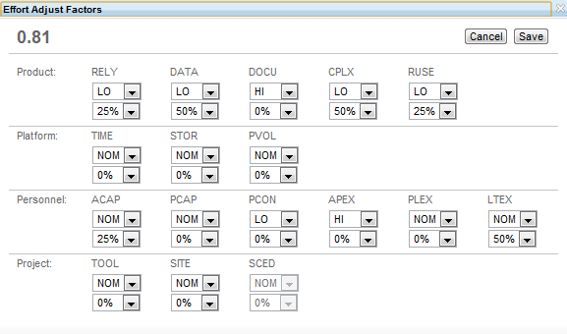

6. Iteration Plan

6.1 Plan
The development of the project is divided into two iterations, and the main milestone is the Core Capability Drive-through (CCD). The capabilities which have higher priorities and risks will be implemented in the first iteration, and the less priority capabilities will be implemented in the second iteration, which occurs after the CCD.

The development phase has a transition iteration which comes after the construction iteration. It begins at the end of the construction iteration two and continues until the end of the semester. The transition iteration accounts for the transition of the system and training if the users and clients.

A detailed plan for the construction and transition iterations of the development phase has been documented in the project plan. Major milestones and products for each iteration can be found in the life cycle plan.

Estimated dates for each iteration are shown below:
- Construction iteration 1: 02/10/2012 - 03/23/2012
- Construction iteration 2: 03/24/2012 - 04/09/2012
- Transition iteration: 04/10/2012- 04/27/2012

6.1.1 Capabilities to be implemented
Iteration 1:
The capabilities to be implemented in the first iteration will be the capability requirements that have a high priority, with low ease of implementation or are required for development of other capability requirements. Also, since the system needs to be integrated with the system being developed by team 4, the capabilities which are required for integration of the two systems are also implemented during the first iteration.
Table 20: Capabilities to be implemented in the iteration 1
Requirement | Description | Priority
CR- 1: Online application for students subject registration | Students should be able to fill in their choices for various subjects. | M (Must have)
CR-2: locking certain classes. | The administration should be able to lock certain classes to certain time frames | M (Must have)
CR-3: Student course requests are viewed/approved/rejected by counselor | The counselor can review all the courses requested by the student and can edit or approve or disapprove the student request | M (Must have)
CR-4: Schedule generation | The system helps the administration in scheduling a time table for the school | M (Must have)
CR-7: Map teachers to course sections | Teachers are assigned a particular course section by the scheduler | M (Must have)
CR-8: View alternate schedules | The administrator can view alternate schedules | M (Must have)
CR-10: LAUSD constraints | The various LAUSD constraints should be entered into the database through a simple UI | M (Must have)
CR-11: Detailed Database | Database to contain student id, course details and teachers id | M (Must have)
LOS-1: System usability | The system will provide an intuitive User interface in order to provide ease of usability | M (Must have)
SR-1: Use given templates by LEMA Pilot School | It is advised to make the user interface according to the given templates and it should be user friendly | M (Must have)
SR-2: Integration with family accountability system | The system should interact with the system being developed by team 04 and get teacher information, student information, and authenticated token | M (Must have)

Iteration 2:
The capabilities to be implemented in the second iterations are all the remaining capability requirements.
Table 21: Capabilities to be implemented in the iteration 2
Requirement | Description | Priority
CR-4: Schedule generation | The system helps the administration in scheduling a time table for the school  Note: this requirement has been developed in the first iteration but it cannot satisfy the requirement, so this requirement needs to be redeveloped and tested. | M (Must have)
CR-10: LAUSD constraints | The various LAUSD constraints should be entered into the database through a simple UI  Note: this requirement has been developed in the first iteration but it cannot satisfy the requirement, so this requirement needs to be redeveloped and tested. | M (Must have)
SR-3: Authentication to the system | The user logs in from the interface from team 04 and in an authenticated session from where it is redirected to our system. Thus we check the cookie to confirm that they were in an authenticated session. The cookie would have user type, user id and authentication key.  Note: this must have requirement cannot be delivered at the first iteration because it need to be integrated with team 4, but team 4 cannot finish related functionality by CCD | M (Must have)
LOS-1: System usability | The system will provide an intuitive User interface in order to provide ease of usability | M (Must have)
CR- 5 : Track the progress of a particular student | Track student progress from A-G requirements for mapping | S (Should have)
CR- 6: Student Progress Enhanced | Ability of students to see how many more credits they need to complete a particular grade | S (Should have)
CR-9: GPA for various universities | Displays how much GPA is required for CSU, U of California and other universities | S (Should have)
CR-12: Level of Normalization | The introduction of a school code which will enable the  scheduling system to be ubiquitous | W (Want to have)

6.1.2 Capabilities to be tested
All the capability requirements that are implemented need to be tested. The list is the same as given in tables above respective to the iterations for which they have been mentioned.

6.1.3 Capabilities not to be tested
There is no capability that does not need to be tested. All capabilities require testing and modules need to be integrated and tested as well.

6.1.4 CCD Preparation Plans
6.1.4.1 CCD Stakeholders

LEMA Pilot School Integrated Scheduling System provides four types of users which are scheduler, counselor, teacher, and student. The client and maintainer are included as CCD stakeholders.

All stakeholders who will be involved in Core Capability Drive-through are summarized as followed.
Table 22: CCD Stakeholders
Stakeholder name | Role
Dr. Supannika Koolmanojwong | - Instructor
Pongtip Aroonvatanaporn | - TA
Roberta Mailman | - Client  - Scheduler  - Teacher
Beth Kennedy | - Client  - Maintainer  - Counselor  - Student
Thammanoon Kawinfruangfukul | - Developer
Eunyoung Hwang | - Developer
David Wiggins | - Developer
Mark Villanueva | - Developer  - Tester
Louis Demaria | - IIV&V  - Tester
Kushalpreet Kaur | - Developer
Sangik Park | - Developer

6.1.4.2 CCD usage scenarios

The usage scenarios of each capability in the first iteration are shown below.
Table 23: CCD usage scenarios
Requirement | Description
CR- 1: Online application for students subject registration | - The student goes to student course registration page  - The student selects courses which are shown following student grade level.  - The student clicks at confirm button
CR-2: locking certain classes. | After the scheduler selects courses that will be open in the current semester, the scheduler can click at lock button to set available courses and allow student to register.
CR-3: Student course requests are viewed/approved/rejected by counselor | After the student selects and registers courses, the counselor can review all the student registered courses.  - The counselor goes to summary page  - The counselor clicks a link on student row that the counselor would like to review.  - The counselor can change selected courses and approval status.  - The counselor clicks at confirm button
CR-4: Schedule generation | After the scheduler import activity list csv file to FET, the scheduler can add constrains and generate the schedule.
CR-7: Map teachers to course sections | - The scheduler goes to teacher assignment page in schedule management  - The scheduler selects the current semester  - The scheduler assigns the teacher to the course.  - The scheduler can click save button to continue finishing teacher assignment later or can click lock button to enable export activity to csv file in Import/Export page
CR-8: View alternate schedules | After scheduler generates the schedule with FET, FET provides website to see possible schedules.
CR-10: LAUSD constraints | Overall student grade level courses:  - The scheduler goes to constrains management page to set overall minimum and maximum number of students for student grade level courses  - The scheduler clicks save button  Specific courses:  - The scheduler goes to course profile page  - The scheduler clicks a link under course name to go to edit course profile page  - The scheduler sets minimum and maximum number of students  - The scheduler clicks save button
CR-11: Detailed Database | The scheduler inputs all data using the phpmyadmin UI into the database.
LOS-1: System usability | The user uses the system to justify the system usability
SR-1: Use given templates by LEMA Pilot School | The user uses the system to review that user interface follow LEMA Pilot School Templates.
SR-2: Integration with family accountability system | The user is able to see information exist in family accountability system

6.1.4.3 CCD preparation plans

1. Implement and test all capabilities in the first iteration, using both informal unit testing and formal testing with test plan by testers.
2. Prepare sample data on the development server for using in the CCD session. The data is provided by the clients and include course information and user id.
3. Prepare user manual and feedback form for all participants
4. In the CCD session, the team introduces and explains the capabilities, test data, and provide all participants with user manual which is on how to use the system, and feedback form which will focus mainly on the design and usability of the system.
5. While participants are using the system, the team observes and records the result and behavior of the participant.
6. Gather the feedback form

6.1.4.4 CCD preparation site and dry run

Before performing the CCD session, the team will setup the system with sample data to the setting environment by connecting the server and client devices via Wireless connection.
In CCD session, the team will present and demonstrate all capabilities in the first iteration of the project and then give the user manual to a participant. Participants test the proposed system following the user manual.
After CCD session, the participants give feedback by filling in the feedback form.

6.1.4.5 Feedback form

Feedback form should include at least entities shown below
Table 24: CCD feedback form layout
Content | Description
No | Document number
Time | Document time
Capability | Which capability will be tested
Description | Detail and guideline for testing
Correctness | Correctness of module, for example, the functionality perform and response correctly based on input data in scale of 0-10
Performance | Performance of module in scale of 0-10
Satisfaction | Satisfaction of module in scale of 0-10
Overall | The overall result of testing in scale of 0-10
Comment | Suggestion or comment added
Signature | Signature of the participant
Date | Date
Note 0 for the lowest score and 10 for the highest score

6.1.4.6 CCD preparation risk management plans
Table 25: CCD preparation risk management plans
Risk | Risk description | Risk management plan
Schedule conflict | Some team members have many assignments due before CCD session, so team members may not have enough time to develop and test some capabilities lead to be not able to finish all capabilities in the first iteration | 1. Prioritize the capabilities according to business value, detail of implementation, and risks.  2. Implement and test the higher prioritized requirements. If there is not enough time to finish all capabilities, the rest of capabilities will be implemented in next iteration.
Requirement mismatch | The team and client may misunderstand the concept of the requirements, so some user interfaces may not easy to use or some capabilities cannot perform properly | The team develops user interface mockup to show and get feedback from the client. Moreover, the team encourages the clients to experience some part of development before CCD session.

6.2 Iteration Assessment
This part of the document records the assessment of implemented capability at the end of each iteration. This version records the end of the first iteration and assessment activity at Core Capability Drive-through (CCD) which allows the client and end-user to have a hand-on experience on the proposed system.

6.2.1 Capabilities Implemented, Tested, and Results
Most of capabilities mentioned in the first iteration plan have been implemented and tested according to test cases shown in Acceptance Test Plan and Cases document; however, CR-4 and CR-10 have been pushed to the second iteration due to requirement changes and less support from the clients.
Table 26: Capabilities implemented, tested, and results in the first iteration
ID | Capability | Test Case | Test Results | If fail, why?
CR- 1 | Online application for students subject registration | TC-01-01, TC-01-02, TC-01-03, TC-01-04, TC-02-01, TC-02-02 | Failed | This requirement cannot pass some test cases because the authentication does not implement (second iteration) and client needs to change the layout and some functionalities in this requirement
CR-2 | Locking certain classes. | TC-03-01, TC-03-02, TC-03-04, TC-03-05, TC-03-08, TC-03-09 | Failed | The implementation of this requirements need to be redeveloped and retested due to the completeness and correctness of the functionality and response
CR-3 | Student course requests are viewed/approved/rejected by counselor | TC-04-01, TC-04-02, TC-04-02a | Passed
CR-7 | Map teachers to course sections | TC-03-01, TC-03-03, TC-03-03a, TC-05-01 | Failed | The functionality does not response correctly when the user would like to undo assign the teachers
CR-8 | View alternate schedules | TC-08-01 | Failed | The FET can provide alternated schedule, but the schedule generation need to be redeveloped and retested.
CR-11 | Detailed Database | TC-06-01 | Passed
LOS-1 | System usability | TC-07-01 | Passed
SR-1 | Use given templates by LEMA Pilot School | N/A | Passed
SR-2 | Integration with family accountability system | TC-02-01, TC-02-02, TC-02-03, TC-03-01, TC-03-03, TC-03-03a, TC-03-04, TC-03-08, TC-04-01, TC-04-02, TC-04-02a, TC-04-03, TC-05-01 | Failed | There are some information needed from team 4, such as student performance, so the team cannot meet this requirement.
Some of capabilities mentioned in the second iteration plan have been implemented and tested according to test cases shown in Acceptance Test Plan and Cases document; however, CR-5, 6, 9 and CR-12 have become evolutionary requirements because team 4 cannot provide relative features as an infrastructure. Moreover, SR-3 cannot finish due to dependencies from team 4. The team collaborates with team 4 to deliver the system.
Table 27: Capabilities implemented, tested, and results in the second iteration
ID | Capability | Test Case | Test Results | If fail, why?
CR- 4 | Schedule generation | TC-02-04,  TC-03-06,  TC-03-07a,  TC-03-07b, TC-05-01,  TC-03-08a | Passed
CR-10 | LAUSD constraints | TC-03-10,  TC-03-10a | Passed
SR-3 | Authentication to the system | TC-01-01,  TC-01-02,  TC-01-03,  TC-01-04 | Failed | This requirement cannot pass because team 4 cannot provide the support functionalities on time.
LOS-1 | System usability | TC-07-01 | Passed

6.2.2 Core Capabilities Drive-Through Results
The core capabilities drive-through results are captured from both the client and developers during the CCD session. There are some capabilities that the client could not capture during the CCD session because of running out time during the CCD, so the team gathered all comments recorded from the team members in the CCD session and then combined with the client’s comments as the CCD results.

Most of capabilities provided in the CCD are met the clients’ expectation and business domain. Some capabilities, such as “Online application for students subject registration” are needed to update to reflect the clients’ needs and be more intuitive when they are displayed in the website. Each page particularly for students should have instructions telling the user what to do. The detail feedback is shown in the table 27.
Table 28: Core capabilities drive-through results
Requirement | User experience | Result
CR- 1: Online application for students subject registration | Driven-through | Positive feedbacks:  - The user interface is easy to use  Improvements needed:  - The students should be able to see the default grade level and advanced courses at the same page  - The layout should be updated to reflect the domain business  - The user interface should display the number of courses that students can take and course name with A – G requirement  - The user interface should display default courses with selected check box.  Changes-to-be-considered:  - In the user interface, is should have a mechanism to detect conflicts and errors, such as conflict courses.
CR-2: locking certain classes. | Demonstrated | Positive feedbacks:  - The functionality works properly  Improvements needed: N/A  Changes-to-be-considered:  - Exporting the activities and locking certain classes should work correspondingly
CR-3: Student course requests are viewed/approved/rejected by counselor | Driven-through | Positive feedbacks:  - The user interface is easy to navigate  - The client was satisfied with the performance and correctness of this capability  Improvements needed:  - An approval status should be approved or remain unapproved  Changes-to-be-considered:  - The user interface should be similar to the student subject registration when the counselor would like to change the selected courses
CR-7: Map teachers to course sections  (this feedback was captured by the team) | Driven-through | Positive feedbacks:  - The user interface is intuitive and easy to use  Improvements needed: N/A  Changes-to-be-considered: N/A
CR-8: View alternate schedules  (this feedback was captured by the team) | Shown | Positive feedbacks: N/A  Improvements needed:  - It should integrate with the schedule generation requirement  Changes-to-be-considered: N/A
CR-11: Detailed Database  (this feedback was captured by the team) | Driven-through | Positive feedbacks:  - The sample data helps the clients understand the system better  Improvements needed:  - The database schema need to be modified by adding isDefaultCourse field in course_detail table and removing denied approval status in approval_status table  Changes-to-be-considered:  - Reflect modified database schema in related pages
LOS-1: System usability | Driven-through | Positive feedbacks:  - The system is easy to navigate and use  Improvements needed:  - Each page should have instructions telling the user what to do.  Changes-to-be-considered:  - The users in the system have different background and skills. Student’s user interface should be the easiest and simplest to use.
SR-1: Use given templates by LEMA Pilot School  (this feedback was captured by the team) | Driven-through | Positive feedbacks:  - The clients are familiar with the user interfaces since the website includes LEMA Pilot School templates  Improvements needed: N/A  Changes-to-be-considered: N/A
SR-2: Integration with family accountability system | Driven-through | Positive feedbacks:  - The information from family accountability system is displayed correctly  Improvements needed:  - The student performance should be displayed in the student progress tracking properly  Changes-to-be-considered: N/A

According to the concern log provided by Ms. Beth Kennedy, all capabilities in the second iteration are important. As a result, the priority of each capability is still the same and needed to be done.

The team realized that there was some misunderstanding in the domain knowledge and it might lead to cause the problems in the future, so the team will identify all possible risks from the CCD session and create mitigation plan.

Table 29: CCD risk management plans
Risk | Risk description | Risk management plan
User interface mismatch | The team may misunderstand the concept of the domain knowledge led to create the user interface which is not reflect clients’ needs | The team develops user interface mockup to show and get feedback from the client.
Schedule shortfall | After finishing the CCD session, there are many changes required in the system and the project schedule is compressed, so it is possible that the team cannot provide all the capabilities | The team asked the clients to reprioritize  capabilities left and focus on the higher  priority capabilities.
Low productivity | The team members have many assignments and get many changes from the CCD, so it is possible that the team productivity will be reduced. | The project manager plans ahead and  gives buffer time to finish team  member’s responsibilities

6.3 Adherence to Plan
Most of capabilities mentioned in the first iteration plan are on the schedule. However, some capabilities need to be redeveloped and retested to meet the project requirements because some of capabilities were required to be updated following the client’s feedback. Three capabilities in the first iteration were deferred to implement and test in the second iteration due to schedule conflicts and developmental dependency on team 4. The team put capabilities which were required redeveloping and retesting and capabilities which were deferred in the second iteration, so these capabilities will be developed and tested.

During developing the project in the first iteration, there were uncertainties occurred such as requirement changes and misunderstanding the concepts between the client and development team. To avoid mistakes, the team will do the prototypes helped all stakeholders understand and give feedback.

In second iteration, team spent time redeveloping and retesting some requirements of the first iteration, so it affected the plan and cause the team not to be able to follow the plan. Moreover, the team 4’s collaboration and commitment played an important role in delivering some requirements. CR-5, 6, 9 and CR-12 became the evolutionary requirements because team 4 could not provide support functionalities. Moreover, SR-3 also depended on team 4. The team tried to mitigate risks by having a backup plan to implement by the team and increasing communication between teams.

